# CPSC 2030 Assignment 1: HTML and CSS review

## Helpful links:

<https://www.w3schools.com/html/>

<https://www.w3schools.com/css/>

## Introduction:

For this assignment you will create a number of static web pages. These pages will be modified in later assignments, but for now they will be static HTML pages, using CSS for styling. In later assignment, you will begin modifying the pages such that they will have content generated using PHP.

The site if for a web application to help restaurants perform contact tracing. Contact tracing is the process in which you find potential people an infected person may have been in contact with, based on the location they have visited and the time they have visited those locations. By having people isolate if they may have been exposed reduces the effective infection rate of the COVID-19 virus.

Each page will have

* Title/Branding section
* Navigation section
* Main Body section
* Footer section

The mockup is shown below:

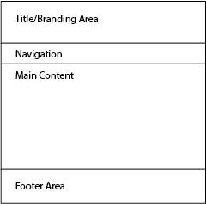

## Site Map

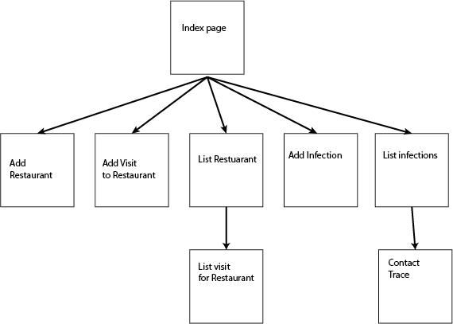

The site map is shown above. It shows the main pages for the site and how they are linked together. For the purpose of the site. For some of the pages, you will create fake data, which will later be filled in via php.

# The pages:

## Index Page: index.html

The index page is the first page a user visits to your site. It generally contains information about the site and has the initial navigation to the site. Create the necessary content for the contact tracing application.

## Add Restaurant: add_restuarant.html

This page is a form used to add restaurant information to the site.

The form contains the fields listed below and you can use the echo.php file as the action and the post method. The echo.php file will display all the submitted data from the form.

|  |  |  |
| --- | --- | --- |
| **Field** | **Type** | **Description** |
| restaurant_name | text | Name of the restaurant |
| phone | tel | Telephone number of the restaurant |
| email | email | e-mail address of restaurant |
| street_address | text | The street address of the restaurant |
| city | text | The city the restaurant is in |
| province | text | The province the restaurant is in |

# Add visit: add_visit.html

This form is for adding visits to a restaurant. In the PHP version of the page, the restaurant field will be a drop down menu in which the restaurant names are populated by PHP.

The form contains the fields listed below and you can use the echo.php file as the action and the post method. The echo.php file will display all the submitted data from the form.

|  |  |  |
| --- | --- | --- |
| **Field** | **Type** | **Description** |
| restaurant | Drop down | Contains restaurant ID as the value, and name of the restaurant is displayed on the page. |
| phone | tel | Phone number of the customer |
| firstname | text | First name of the customer |
| lastname | text | Last name of the customer |
| timein | datetime-local | The date and time the customer arrived |
| timeout | datetime-local | The date and time the customer left |

# List restaurants:list_restaurants.html

This page list all the restaurants in the database in a table. It has an additional column that links to link the visits for that particular restaurant. For now, the visit by restaurant can be a static page. When we get to PHP this page will the dynamically generated with PHP such that it contains the correct information.

|  |  |  |
| --- | --- | --- |
| **Column** | **Type** | **Description** |
| restaurant_name | text | Name of the restaurant |
| phone | tel | Telephone number of the restaurant |
| email | email | e-mail address of restaurant |
| street_address | text | The street address of the restaurant |
| city | text | The city the restaurant is in |
| province | text | The province the restaurant is in |
| visits | link | A link to the page the will list the visits by restaurant |

# List of visits: visit_by_restaurant.html

This page list all the visits for a restaurant. In the final version, the information will on be for a single restaurant, with the restaurant selected through the query parameter.

|  |  |  |
| --- | --- | --- |
| **Column** | **Type** | **Description** |
| restaurant | Drop down | Contains restaurant ID as the value, and name of the restaurant is displayed on the page. |
| phone | tel | Phone number of the customer |
| firstname | text | First name of the customer |
| lastname | text | Last name of the customer |
| timein | datetime-local | The date and time the customer arrived |
| timeout | datetime-local | The date and time the customer left |

# Add Infection:add_infection.html

The add infection page, allows customers to report and infection. This data will then be used to perform contact tracing. The form contains the fields listed below and you can use the echo.php file as the action and the post method. The echo.php file will display all the submitted data from the form.

|  |  |  |
| --- | --- | --- |
| **Field** | **Type** | **Description** |
| phone_number | tel | The phone number of the customer, which will be use to identify them in the visit data. |
| firstname | text | First name of the customer |
| lastname | text | Last name of the customer |
| test_center | text | The location the test was performed |
| test_date | date | The date the COVID-19 test was performed |
| start_date | date | The estimated start date of the infection |
| end_date | date | The end_date of the infection, if left empty it should default to the current date |

# List of infection: infections.html

This page is a table containing the information that was entered for an infection, as well as a link to initiate a contact trace.

|  |  |  |
| --- | --- | --- |
| **column** | **Type** | **Description** |
| phone_number | tel | The phone number of the customer, which will be use to identify them in the visit data. |
| firstname | text | First name of the customer |
| lastname | text | Last name of the customer |
| test_center | text | The location the test was performed |
| test_date | date | The date the COVID-19 test was performed |
| start_date | date | The estimated start date of the infection |
| end_date | date | The end_date of the infection, if left empty it should default to the current date |
| contact_trace | link | A link to the contact trace page, which will list all the people who were in contact with the customer. |

# Contact Trace: contact_trace.html

The contact trace will accept the infection as an input parameter, and then list all the other people who have come into contact with that person. This will be implemented in PHP in a later assignment. For now, create a table with the following data. Please make up some data for now.

|  |  |  |
| --- | --- | --- |
| **Column** | **Type** | **Description** |
| restaurant_name | text | Name of the restaurant |
| phone | tel | Phone number of the customer |
| firstname | text | First name of the customer |
| lastname | text | Last name of the customer |
| timein | datetime-local | The date and time the customer arrived |
| timeout | datetime-local | The date and time the customer left |
|  |  |  |

# Submission

* Please put style sheets in the styles folder
* Please place any images in the folder img
* create appropriate directories for other content
* Zip the directory your website is stored in, into a single zip file called Assignment1.zip
* Upload the file to the assignment folder.